Assignment 2

Submitted to

Sri Lanka Institute of Information Technology

Submitted on

17-May-2022

IT20187828

Y3S1-WD.5.2

Isurika M.D.A

Step 1: Data Source for the Assignment

Data warehouse includes bank loan details which is given to countries to continue their large developing projects. It includes all the loan bank statement details which issues on the last day of every month.

I have designed the data warehouse using **Snowflake Schema.**

Fact table have relationship with Loan dimension and Date dimension. Then Loan dimension is connected to project dimension. And Project dimension is connected to Country dimension.

Step 2: SSAS Cube Implementation

Step1: open new analysis services multidimensional and data mining project.

Step2: then inside data sources folder create new data source to connect with data warehouse (IBRD_DW).

Step3: next inside data source views folder creates new data source view by including all the necessary dimension tables and fact tables.

Step4: next inside cube folder create cube by including only necessary fields which needs for analyzing purposes.

Step5:deploy the cube and import to the MS Studio.

Data Source View

Cube Structure

Dim Loan Data Source View

Dim Date Data Source View

Step 3: Demonstration of OLAP Operations

Step1: I have connected data warehouse to excel workbook by using power pivot option.

** by following steps as below mentioned.

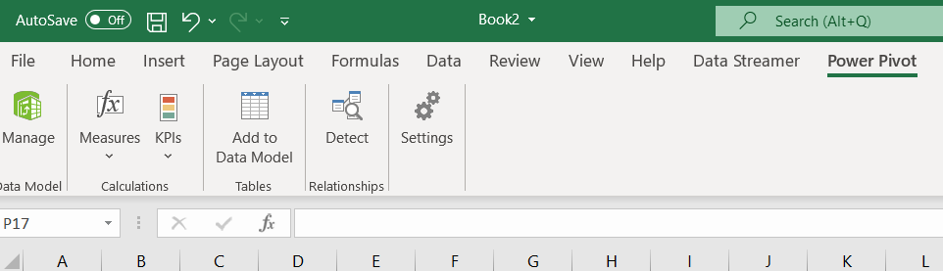

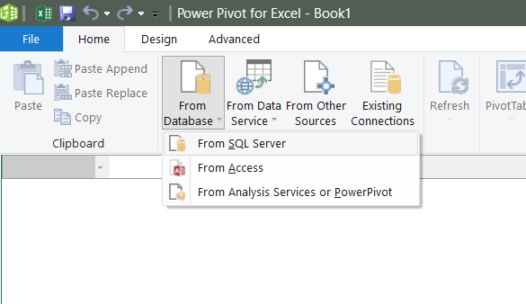

Demonstration of OLAP Operations

Roll up Operation

Drill-down operation

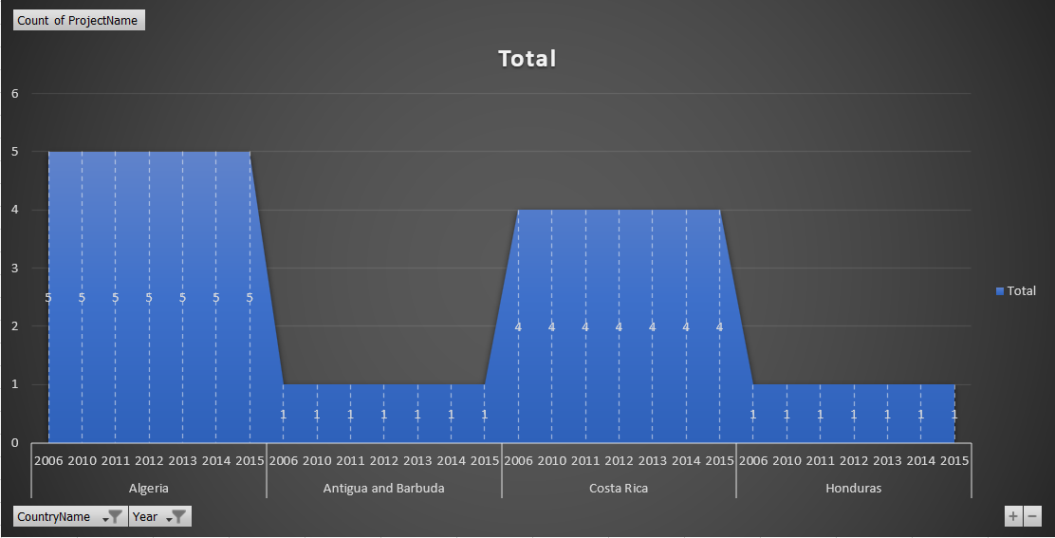

Slice operation

Dice Operation

Pivot Operation

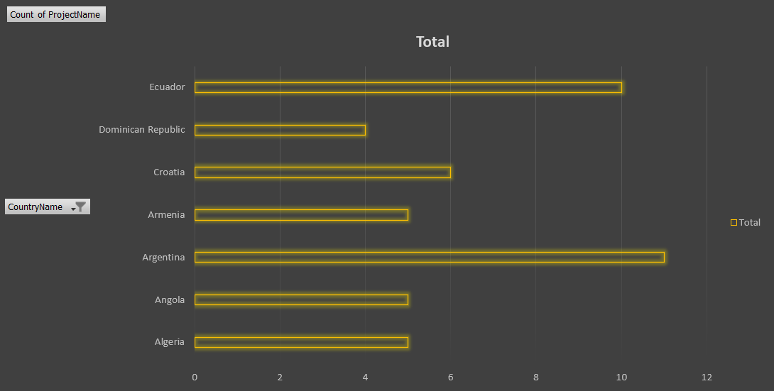

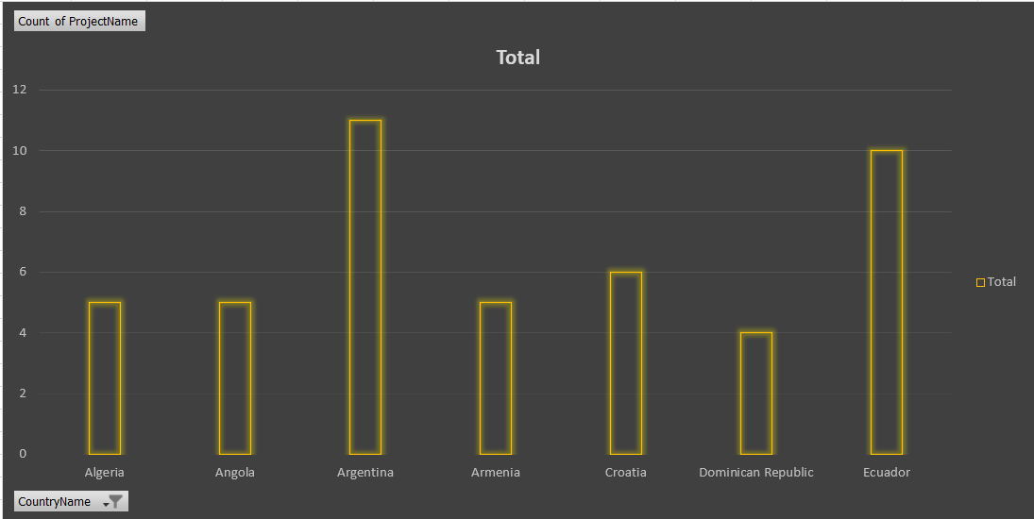

Step 4: SSRS Reports

Step1: first I have connected with the Report Server Configuration Manager

Step2: then open report builder application.

Step3: then configure data source build-in field by adding Data warehouse as IBRD_DW.

Step4: then add all the dimension tables by implement some joining queries inside the data sets build-in filed.

Step5: then do some other configurations like add parameters to generate different types of reports as needed.

Step6: as the last step after all configurations go to INSERT tab and choose table wizard or matrix wizard or charts to create the report.

